**Question:**

Business model Customer to Customer (C2C) allows customers to do business with each other. This model is growing fast with e-commerce platforms where sellers may be required to pay some amount and buyer can buy it without paying anything. E-Commerce website brings the seller and buyer to the same platform.

Analyzing the user's database will lead to understanding the business perspective. Behaviour of the users can be traced in terms of business with exploration of the user’s database.

Dataset: One .csv file with name users_data with 98913 rows and 27 columns

1. Create new schema as ecommerce.

create database ecommerce;

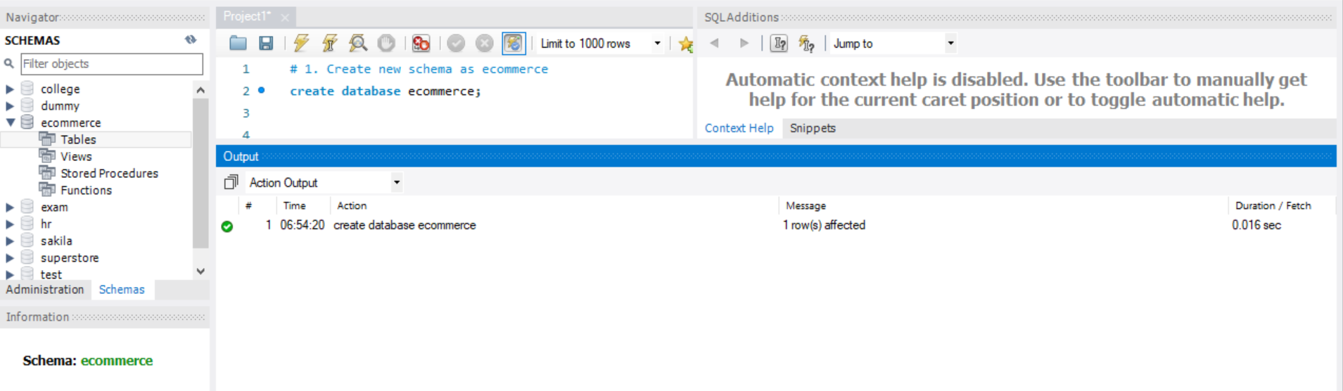

1. Import .csv file users_data into MySQL  
   (right click on ecommerce schema -> Table Data import Wizard -> Give path of the file -> Next -> choose options : Create a new table , select delete if exist -> next -> next)

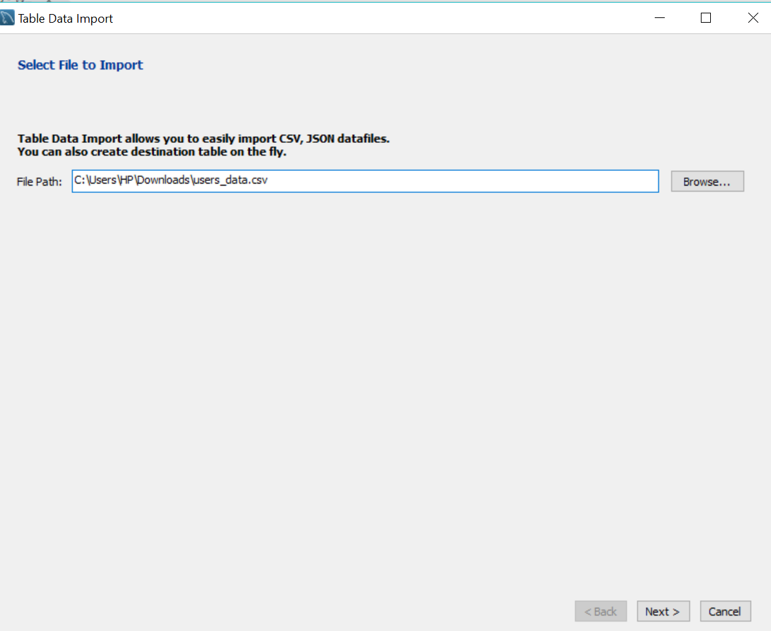

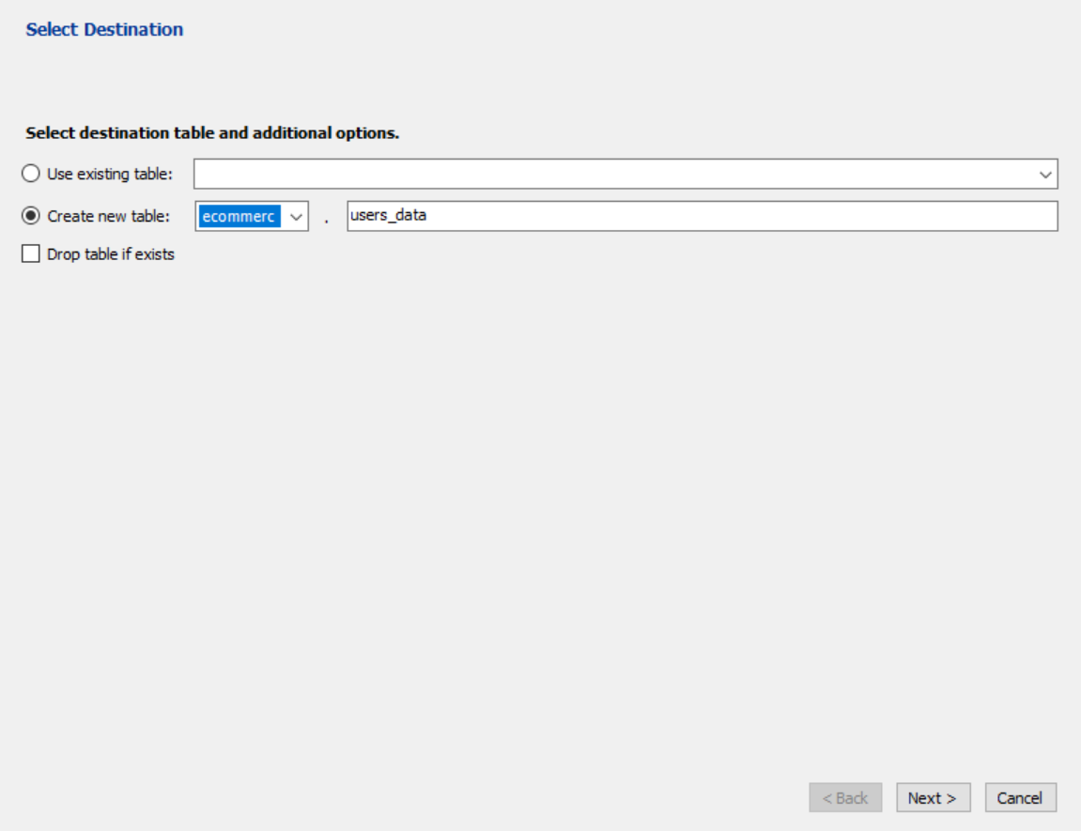

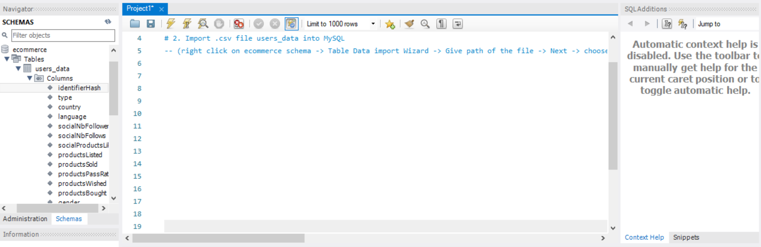

1. Run SQL command to see the structure of table

use ecommerce;

desc users_data;

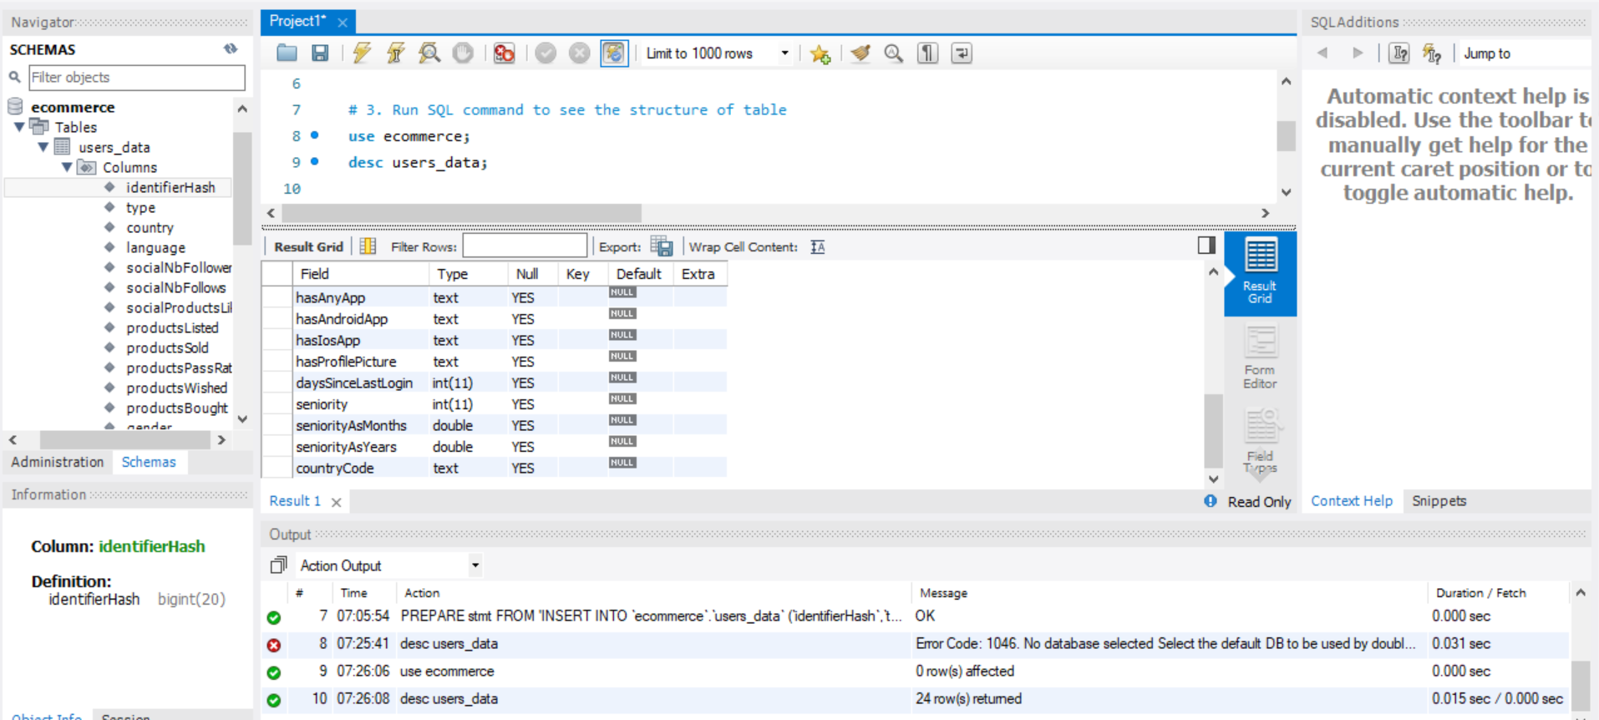

1. Run SQL command to select first 100 rows of the database

select * from users_data limit 100;

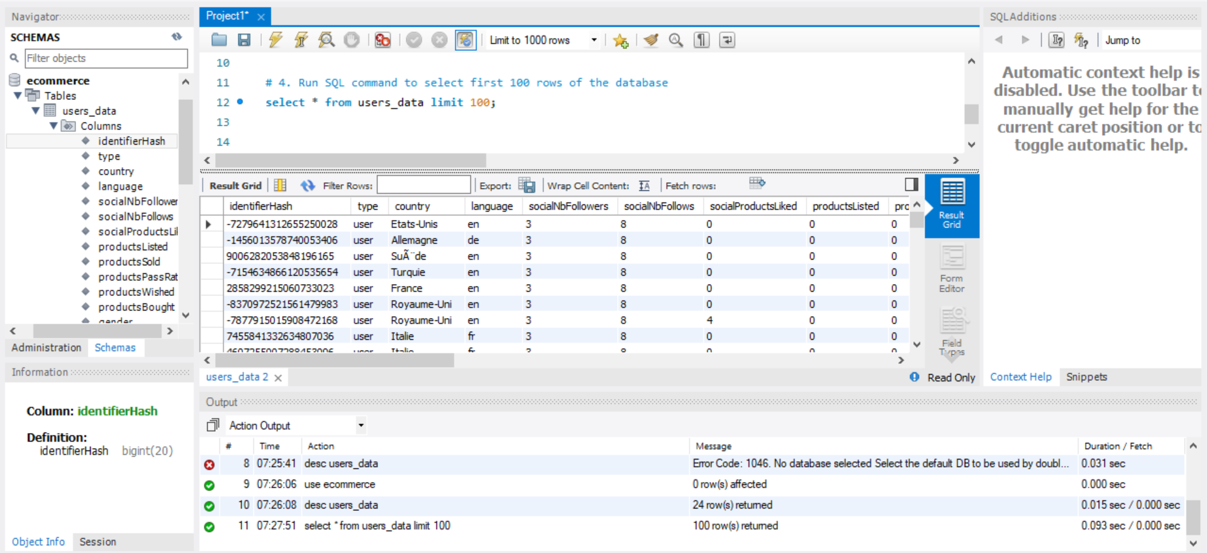

1. How many distinct values exist in table for field country and language

select count(distinct country) country, count(distinct language) language from users_data;

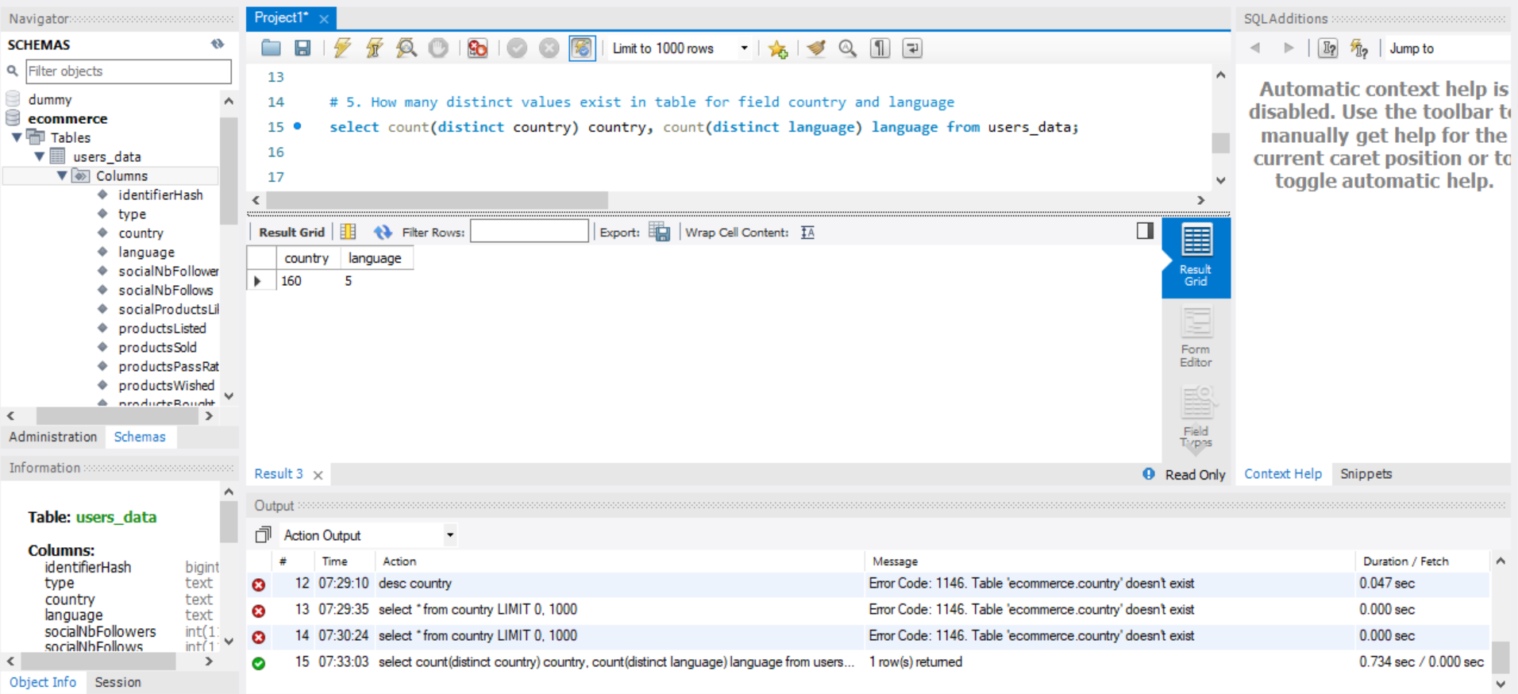

1. Check whether male users are having maximum followers or female users

select gender,sum(socialNBFollowers) from users_data group by gender;

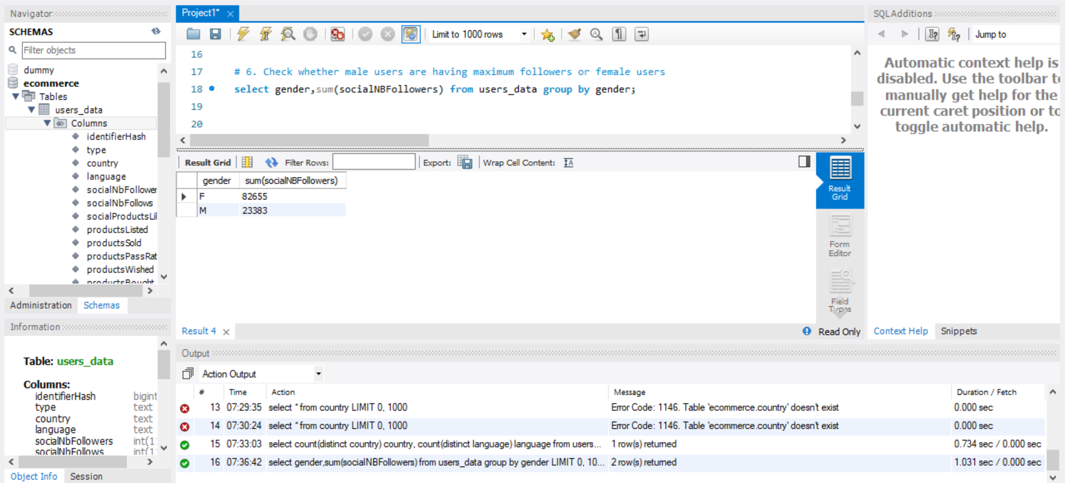

1. Calculate the total users those

-- a) Uses Profile Picture in their Profile

select count(hasProfilePicture) Users_with_ProfilePicture from users_data where hasProfilePicture = 'True';

-- b) Uses Application for Ecommerce platform

select count(hasAnyApp) Users_with_Anyapp from users_data where hasAnyApp = 'True';

-- c) Uses Android app

select count(hasAndroidApp) Users_with_AndroidApp from users_data where hasAndroidApp = 'True';

-- d) Uses ios app

select count(hasIosApp) Users_with_IosApp from users_data where hasIosApp = 'True';

1. Uses Profile Picture in their Profile

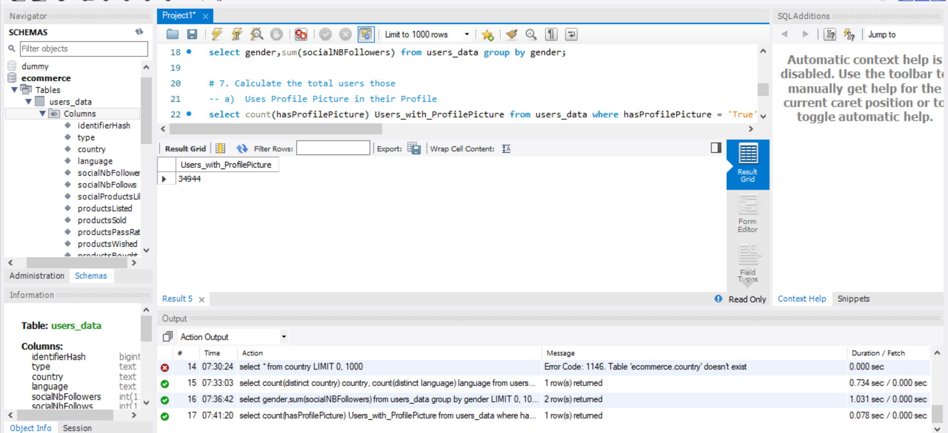

1. Uses Application for Ecommerce platform

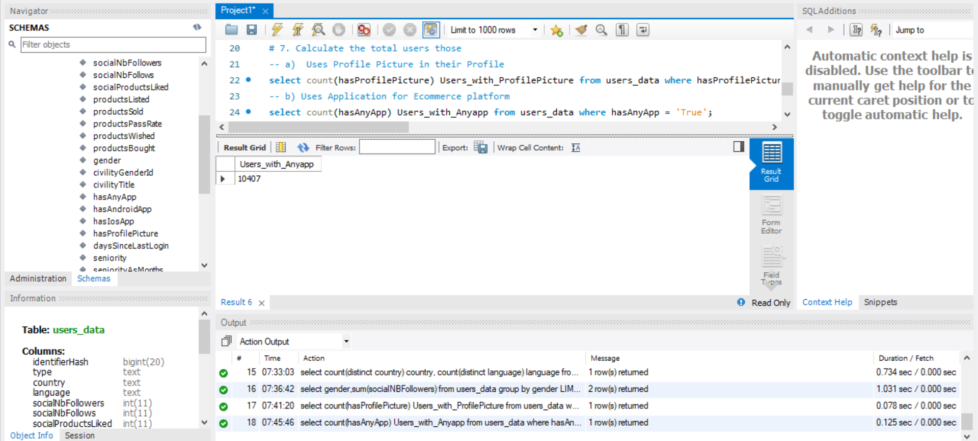

1. Uses Android app

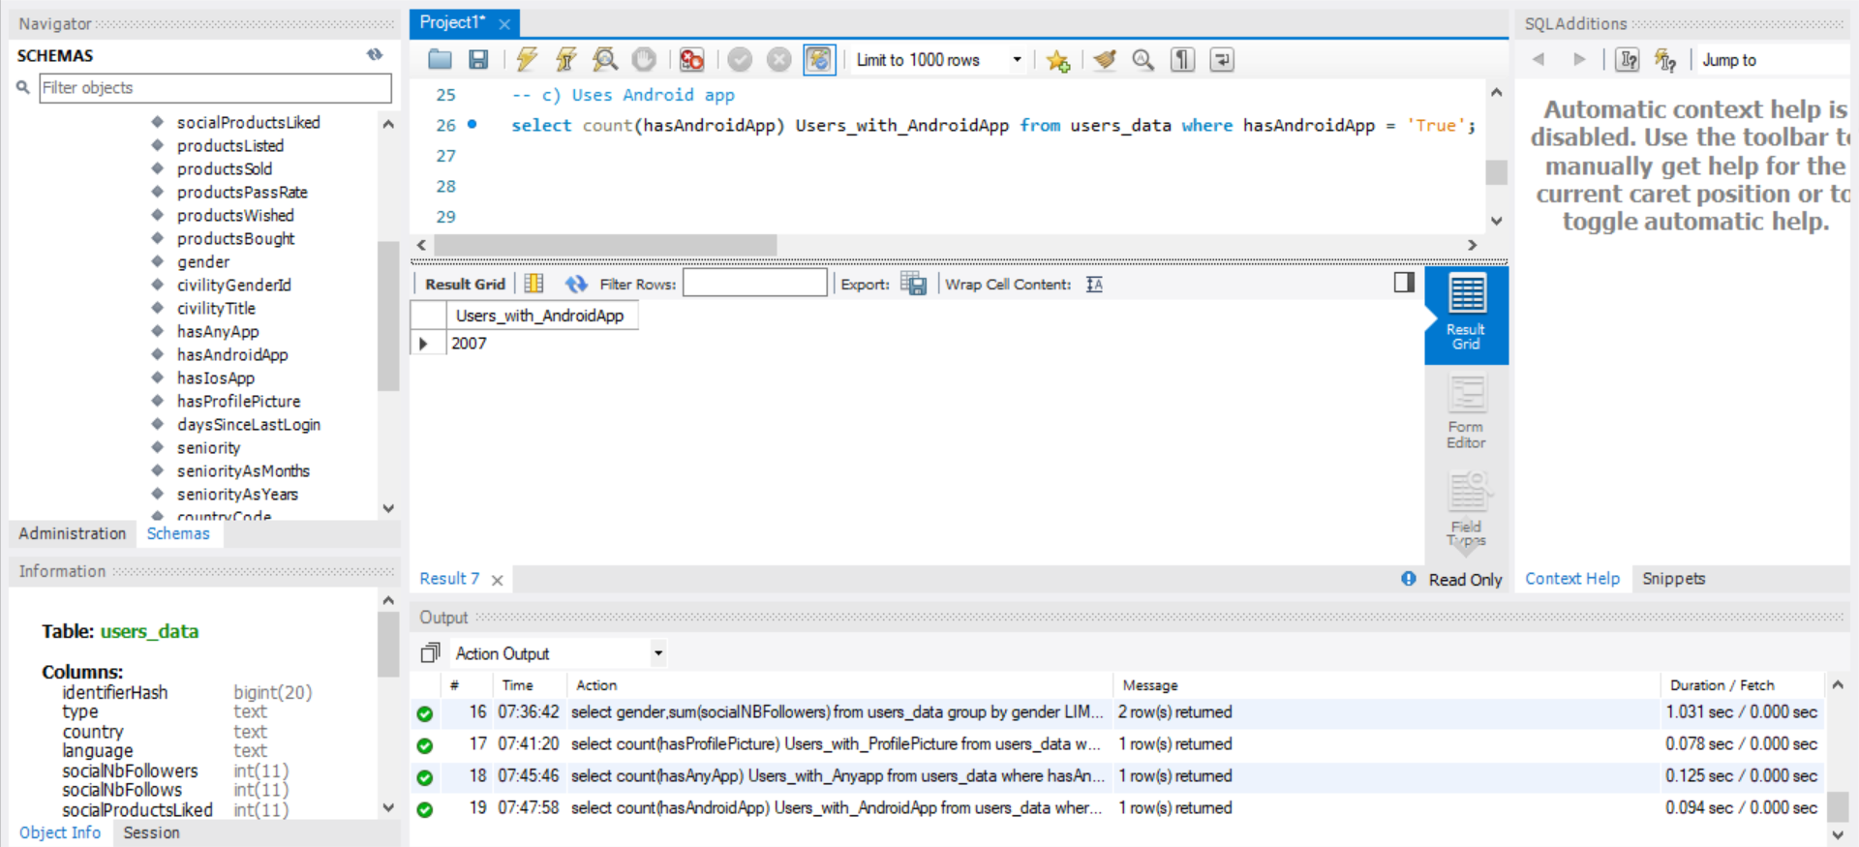

1. Uses ios app

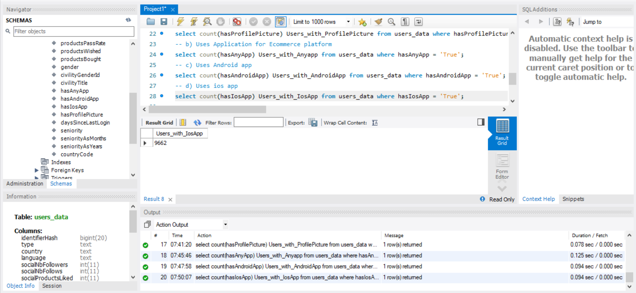

1. Calculate the total number of buyers for each country and sort the result in descending order of total number of buyers. (Hint: consider only those users having at least 1 product bought.)

select country,count(productsBought) Buyers from users_data group by country order by Buyers desc;

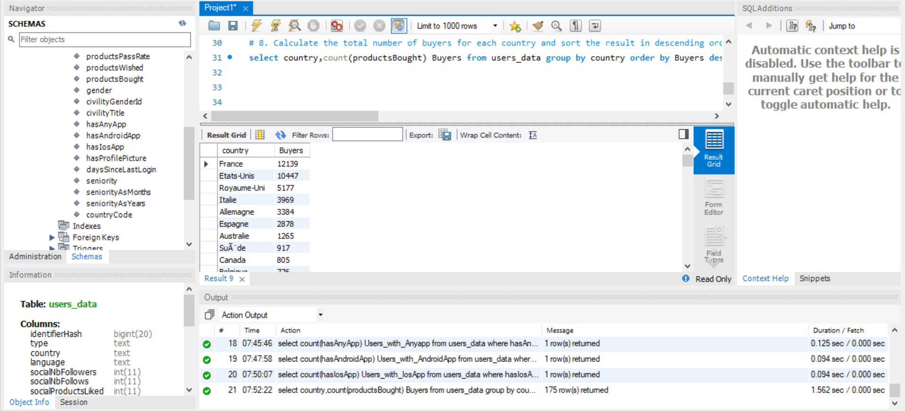

1. Calculate the total number of sellers for each country and sort the result in ascending order of total number of sellers. (Hint: consider only those users having at least 1 product sold.)

select country,count(productsSold) Sellers from users_data group by country order by Sellers asc ;

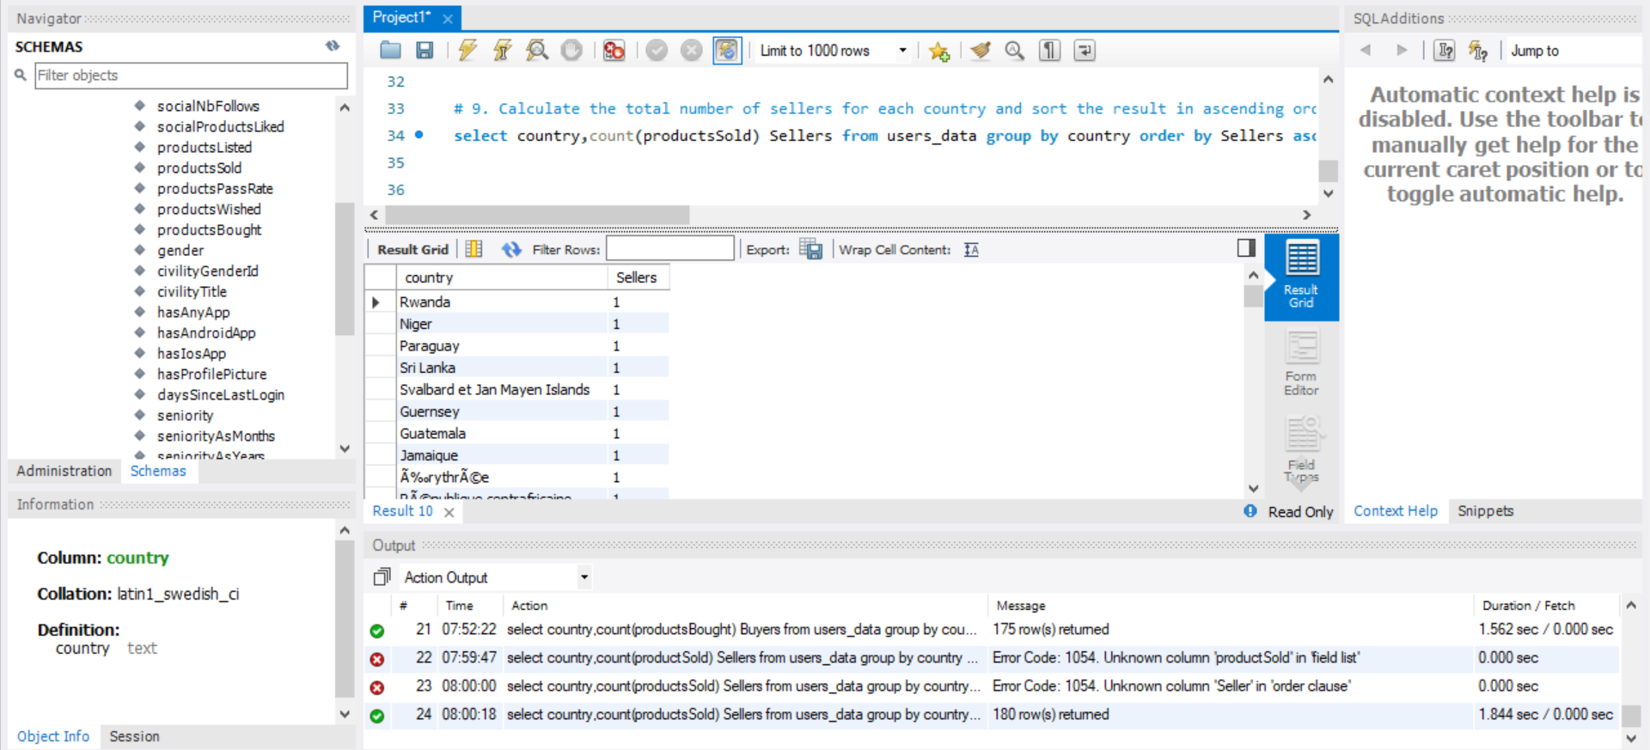

1. Display name of top 10 countries having maximum products pass rate.

select country from users_data group by country having max(productsPassRate) limit 10;

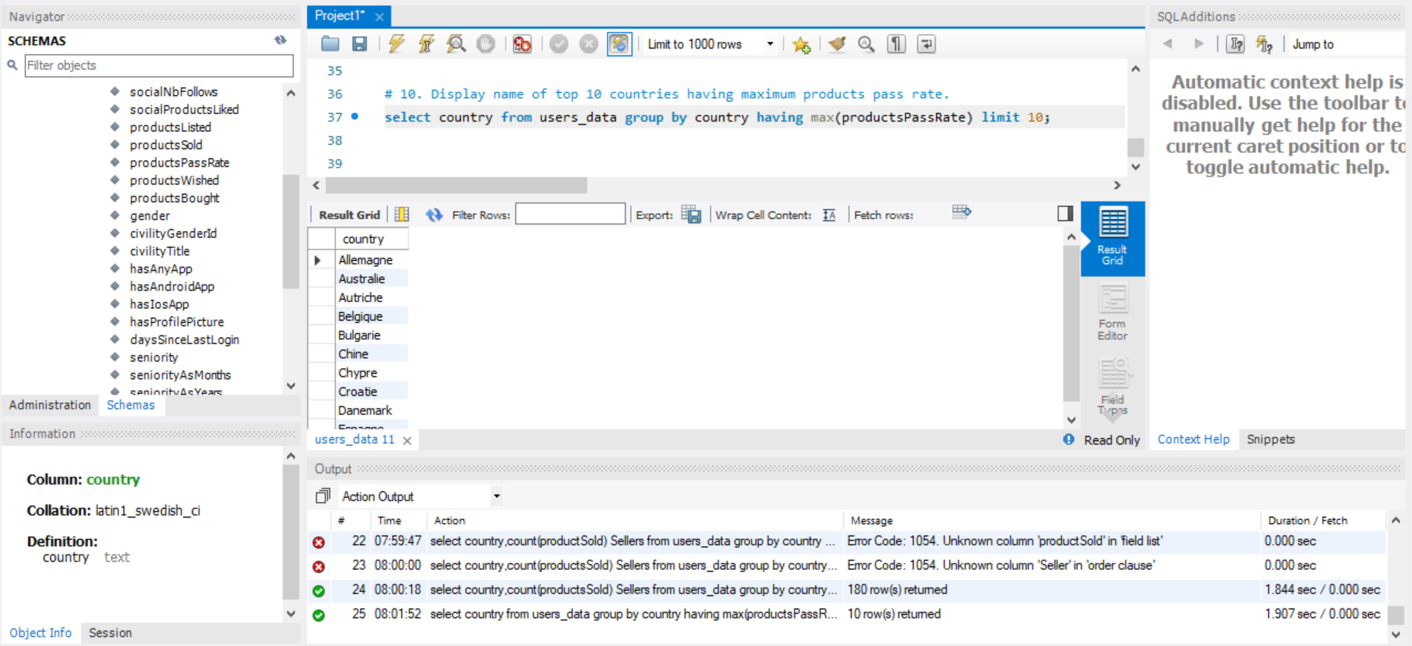

1. Calculate the number of users on an ecommerce platform for different language choices.

select language,count(language) from users_data group by language;

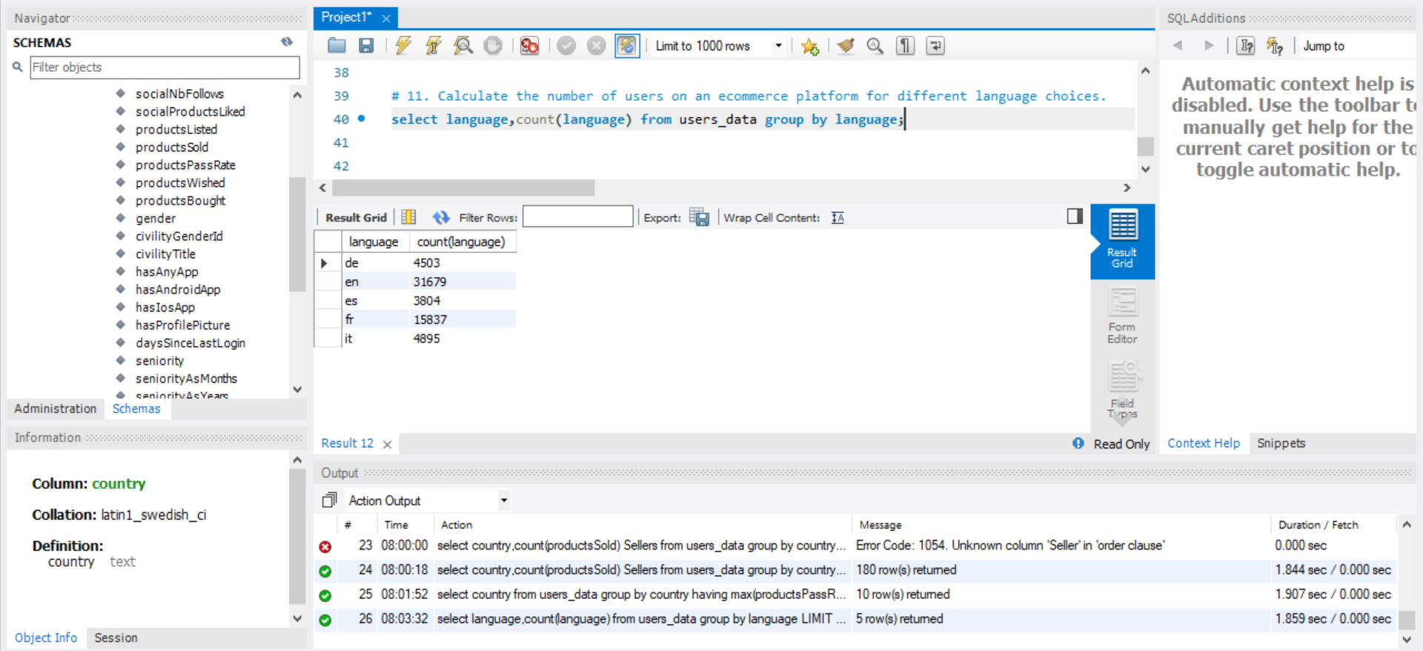

1. Check the choice of female users about putting the product in a wishlist or to like socially on an ecommerce platform. (Hint: use UNION to answer this question.)

select sum(productsWished) ,sum(socialProductsLiked) from users_data where gender='F';

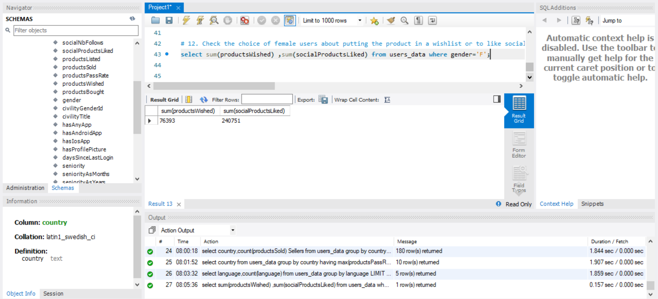

1. Check the choice of male users about being seller or buyer. (Hint: use UNION to solve this question.)

select count(productsSold),count(productsBought) from users_data where gender='M';

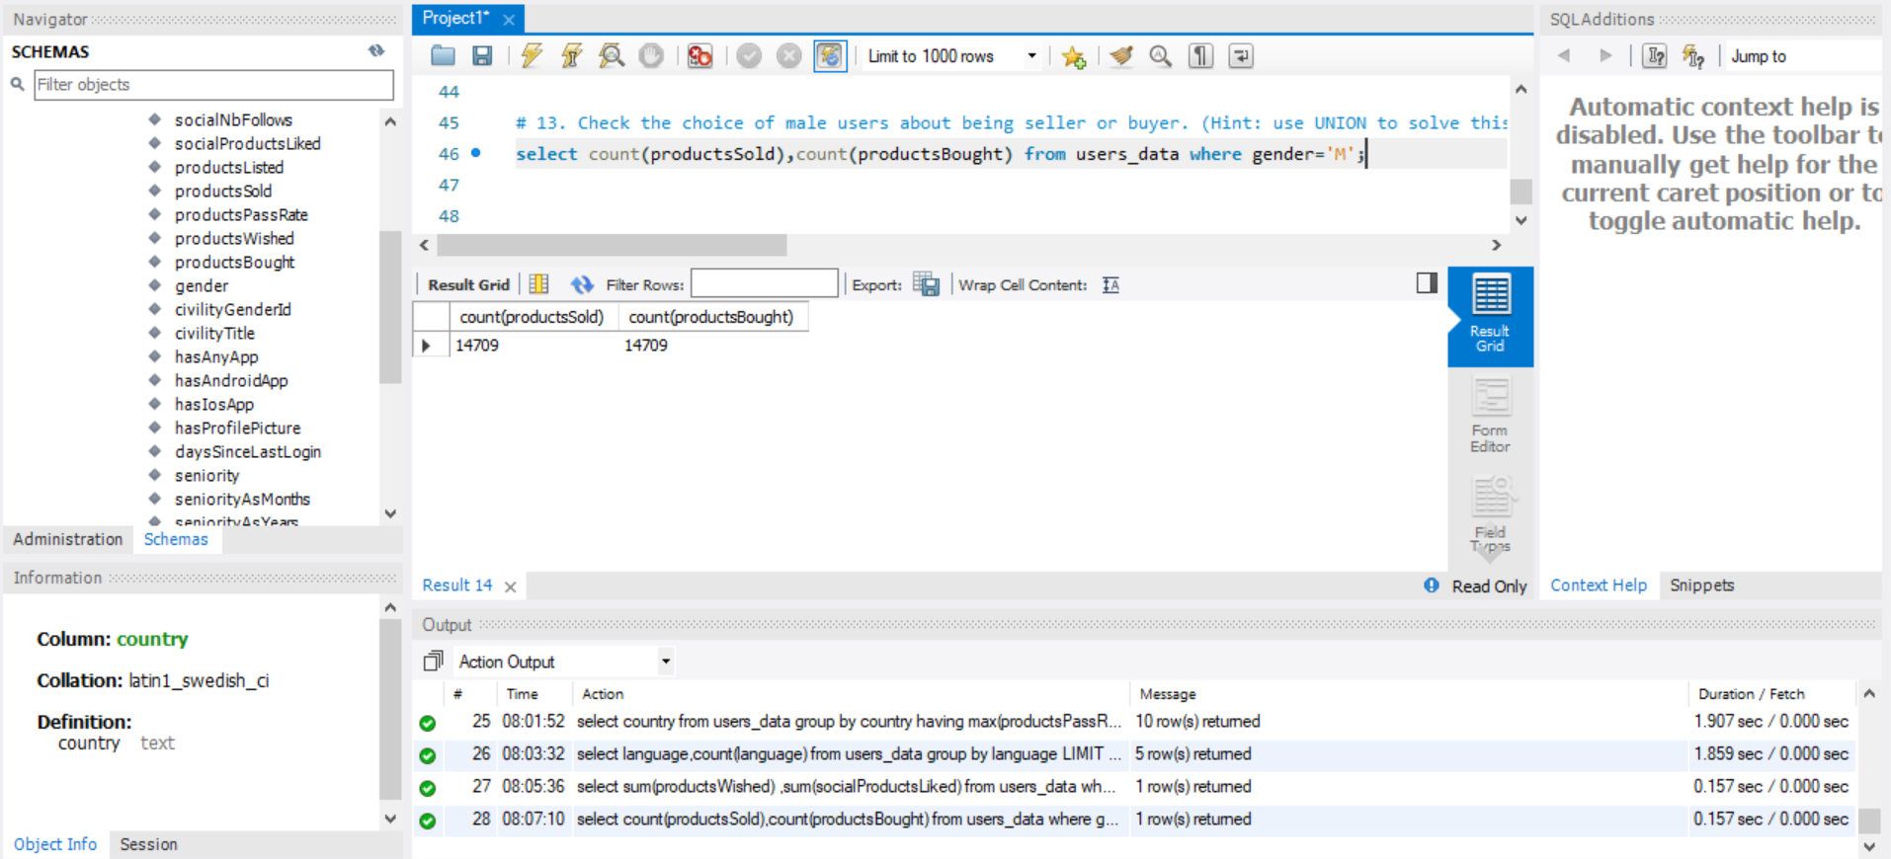

1. Which country is having maximum number of buyers?

select country,max(productsBought) Max_no_of_buyers from users_data group by country order by max(productsBought) desc limit 1;

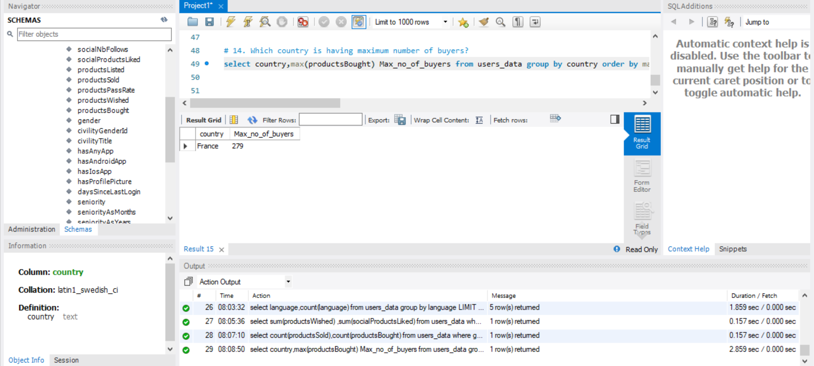

1. List the name of 10 countries having zero number of sellers.

select country , productsSold from users_data where productsSold=0 limit 10;

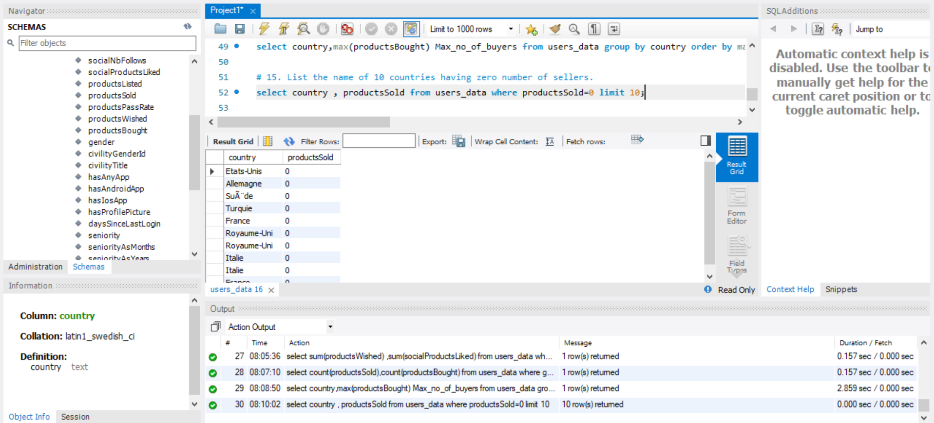

1. Display record of top 110 users who have used ecommerce platform recently.

select * from users_data group by daysSinceLastLogin having min(daysSinceLastLogin) order by daysSinceLastLogin asc limit 110;

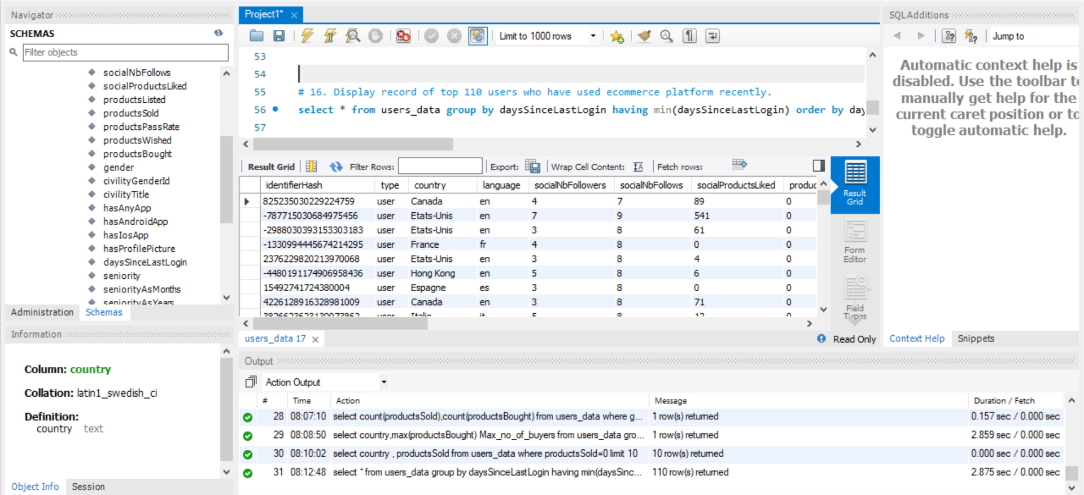

1. Calculate the number of female users those who have not logged in since last 100 days.

select count(type) from users_data where gender='F' and daysSinceLastLogin >= 100;

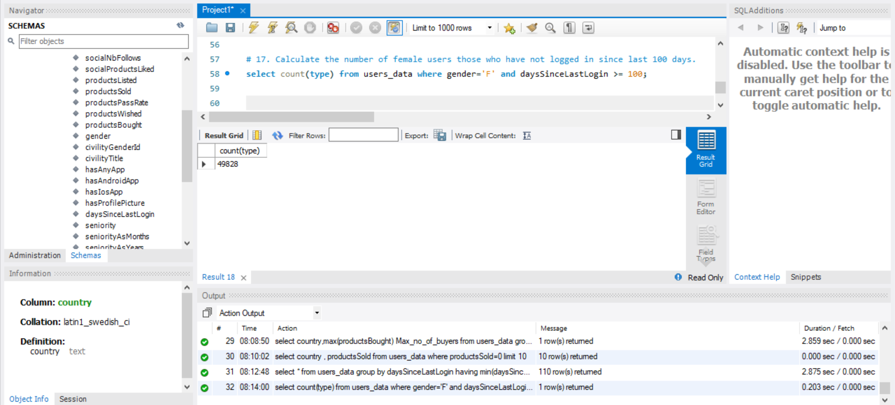

1. Display the number of female users of each country at ecommerce platform.

select country,count(gender) Female_users from users_data where gender='F' group by country;

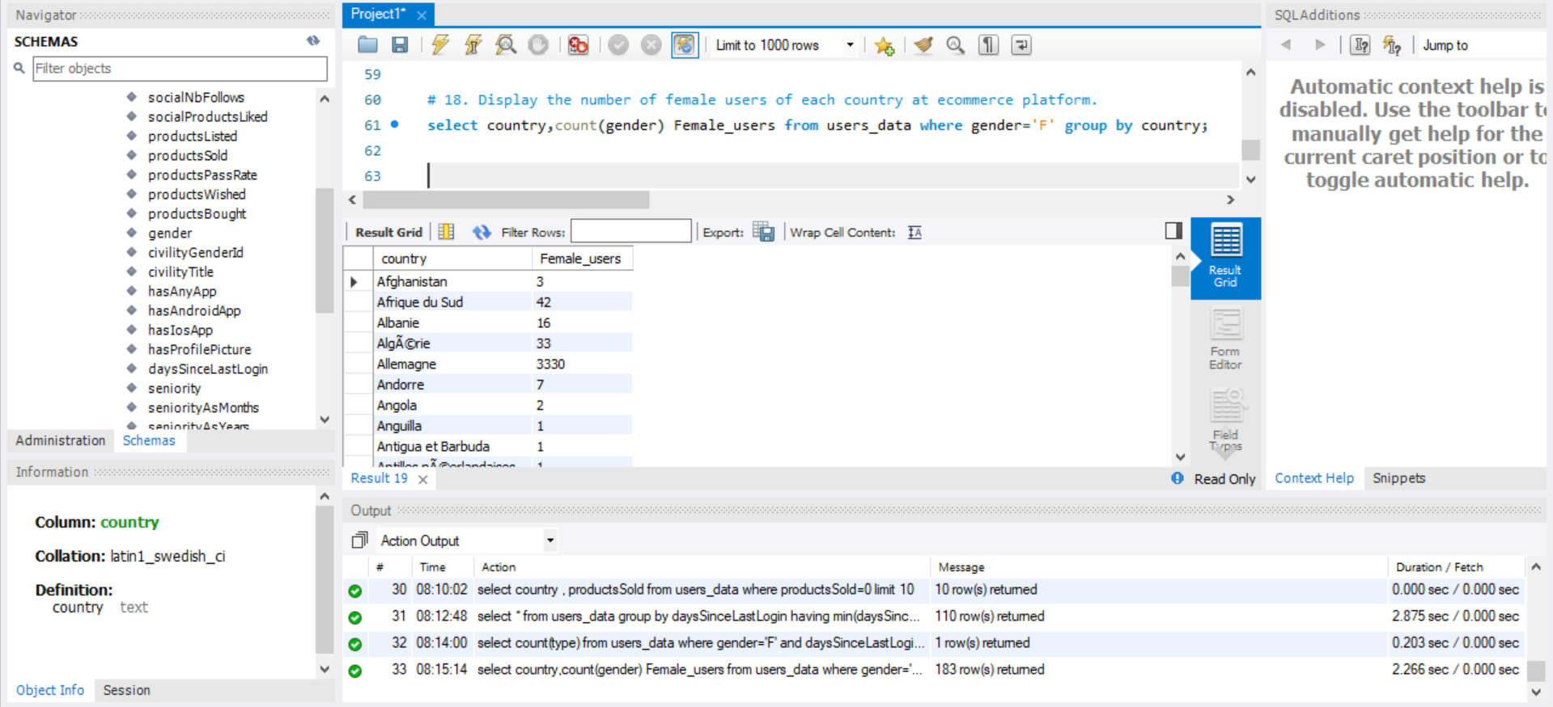

1. Display the number of male users of each country at ecommerce platform.

select country,count(gender) Male_users from users_data where gender='M' group by country;

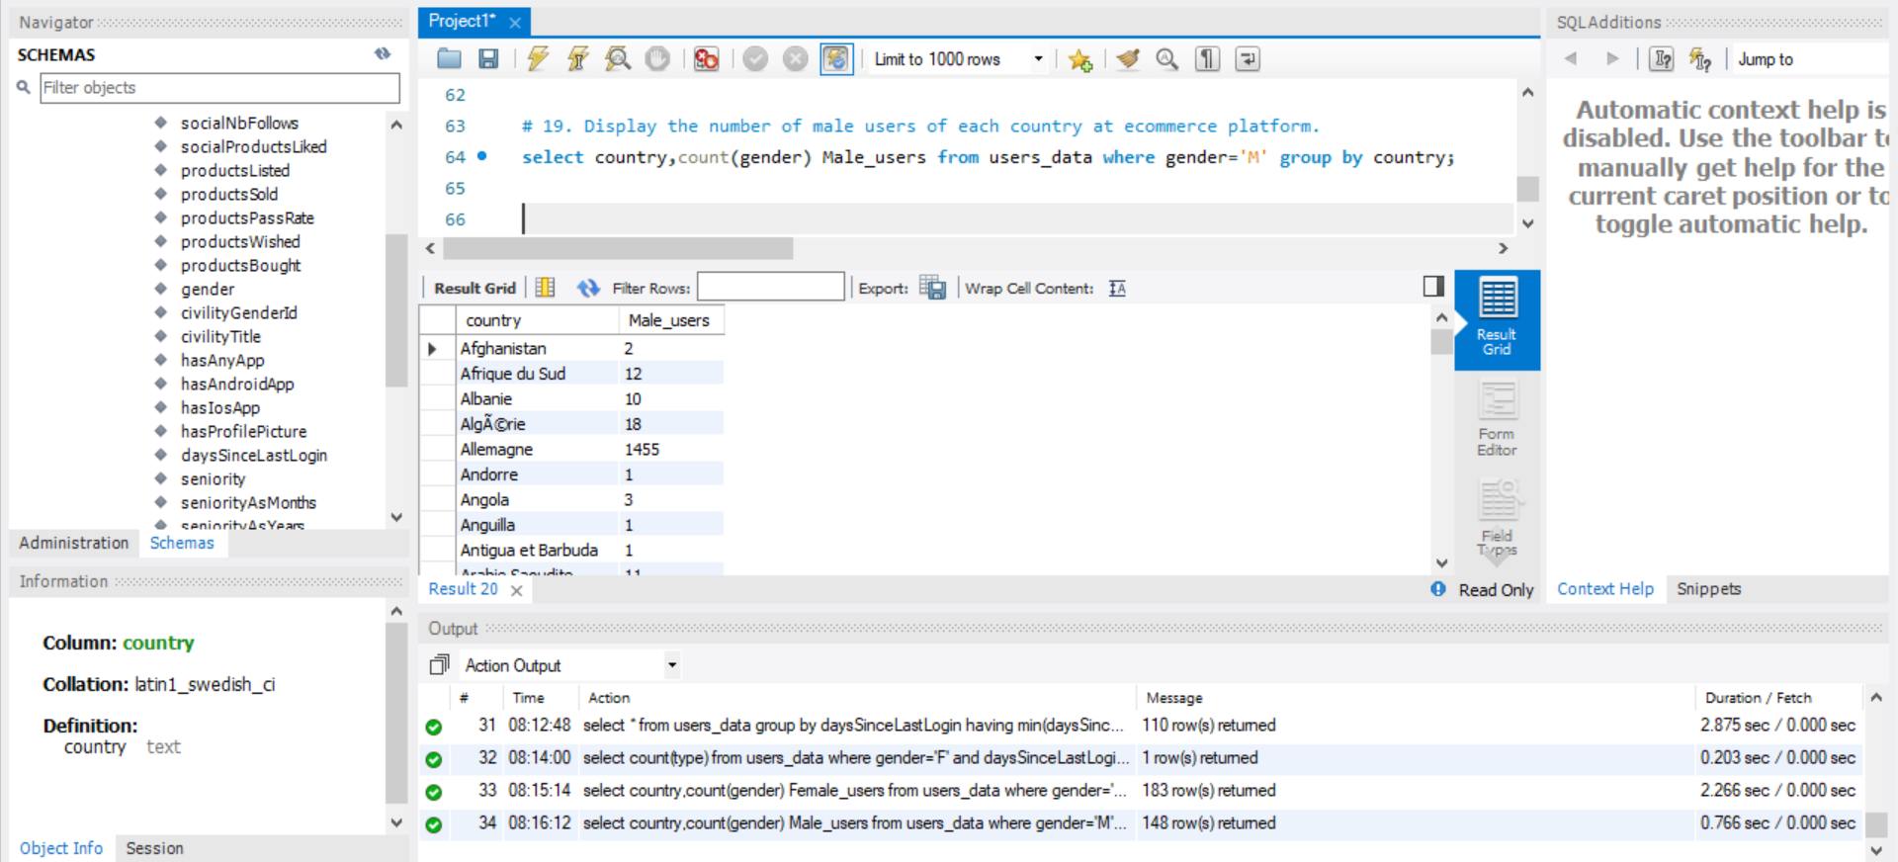

1. Calculate the average number of products sold and bought on ecommerce platform by male users for each country.

select country,avg(productsSold) Products_sold,avg(productsBought) Products_bought from users_data where gender='M' group by country;

